Group Registration Guideline for MedInfo2017
NOTE： Group registration is only for foreign delegates, and
minimum members of a group is 10 persons.
1. Open the website and click the “Group Registration” .
2. Sign in with your team account, or create an account if you don’t have.
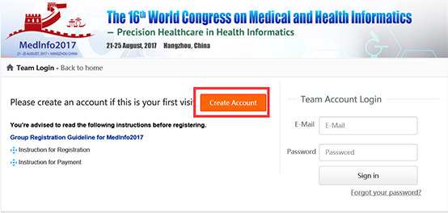
3. Fill out relevant information and click”Confirm registration” to complete the account registration.
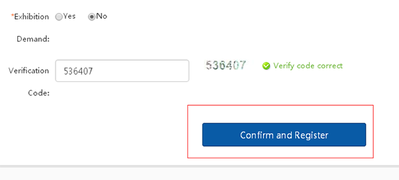
4. Click ”Next” then you will enter into individual homepage。
5. Click “Add Delegates” to add the members of your group. If the member already registered, please
input the name to search, then choose the correct the membership click ”Submit information” to add
the members of your group.
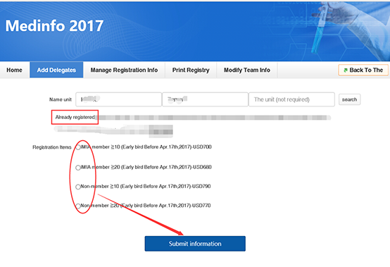
6. If the member haven’t registered yet, please click ”Click Add” to create a new individual account for your members, and click “Submit Information” to complete their registration.
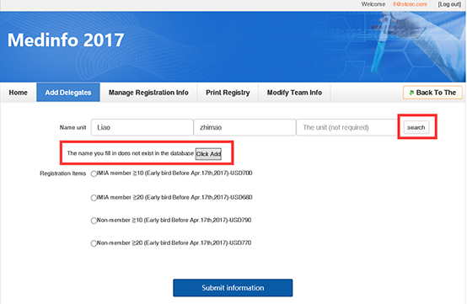
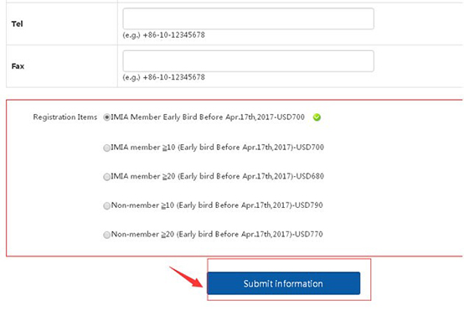
7. After adding the required number of members (at least 10 members in your group) of each registration
type, you can click “Manage Registration Info” for the payment. Choose the members first and then
click “Online Pay” button.
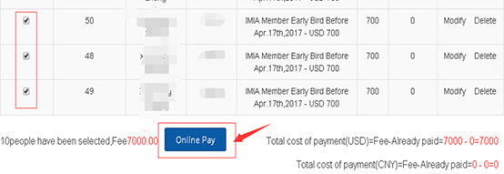
8. Choose ”Online Pay” It will jump to the PayEase, then you can choose the type of credit card you
want to use and fill out the required information. And click the continue button to complete the payment.
