Individual Registration Guideline for MedInfo2017
1. Open the website www.medinfo2017.org and click the “Individual Registration” .
2. Sign in with your account, or create an account if you don’t have one.
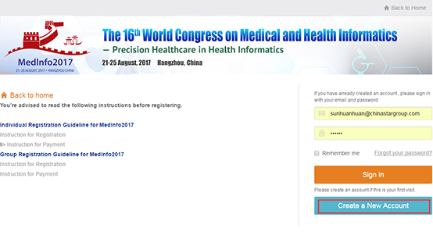
3. Fill out the forms, click ”confirm and Register” to complete the registration.
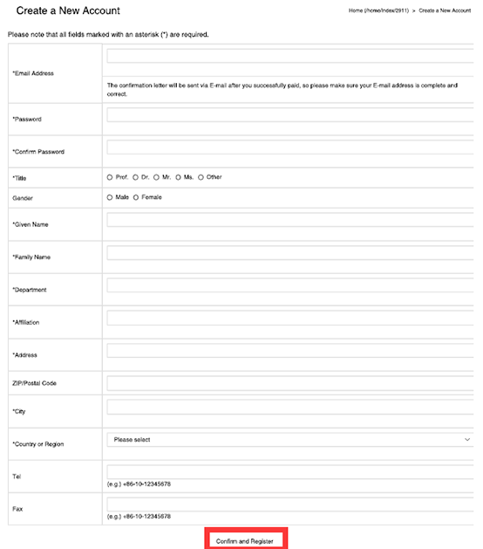
4. Click ”Next” then you will enter into individual homepage。
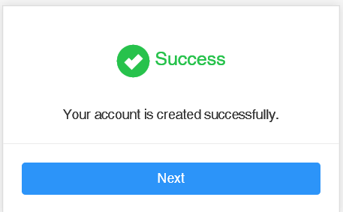
5. Click ”Personal Information” can do the changes.
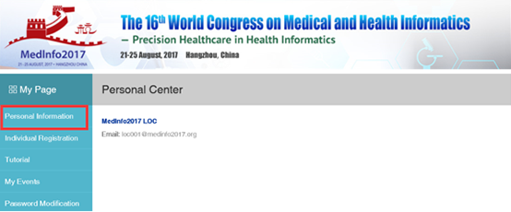
6. Click ”Individual Registration”, choose the correct membership, and have the payment.
Please note you cannot choose “Tutorial” separately.
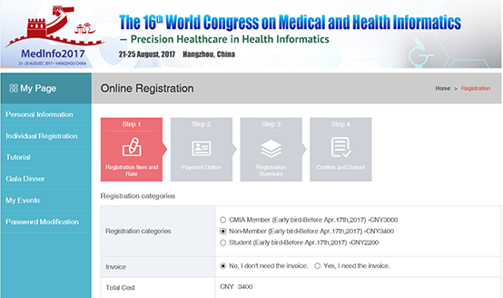
7. Click ”Confirm” to do the next step.The system will automatically create the registration
number upon submission, and then you can choose the payment option of “Credit Card
Online” and click the “Confirm my registration” button.
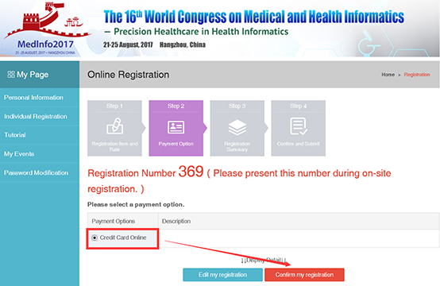
8. A pop-out will appear and you need to click the “Confirm and Pay” button to pay the
amount via “PayEase”.
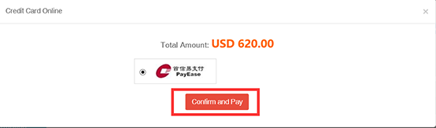
9. If you pay by USD, please choose the type of credit card you want to use and fill out the
required information. And click the “Continue” button to complete the payment.
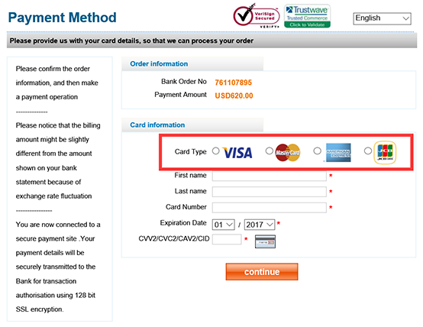
10. If you pay by RMB, please choose the bank type and submit.
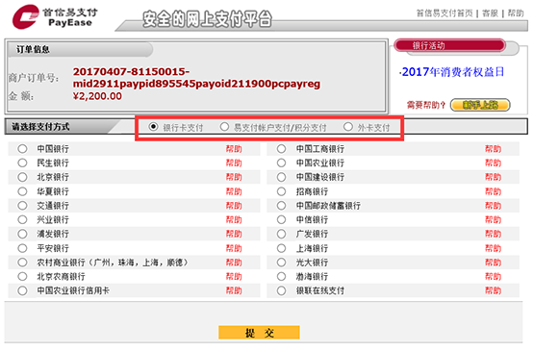
11. If the payment is failed, go back to the popup, click ”Payment is failed, please click here
to try again” to try again.
If the payment is successful, click ” Payment is successful, please click here to confirm”
to go back to individual homepage again.
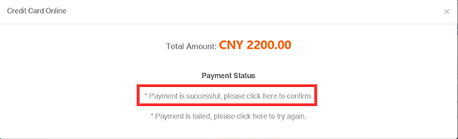
12. You would find the registration is totally complete, you can click”Print Registration
Form” to get a confirmation form.
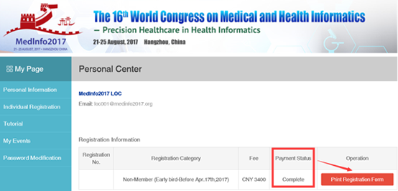
13. Check the detailed confirmation form carefully。
